SANTOSH KUMAR VISHWAKARMA

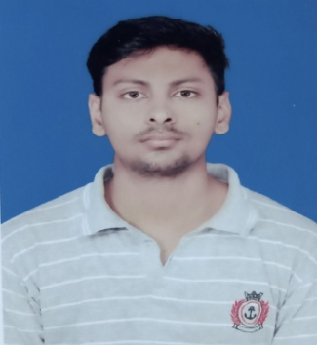 **About Me**

### 05th Jan, 1998

+91 8987986635



[Santoshn2704@gmail.com](mailto:Santoshn2704@gmail.com) Ramgarh cantt, Jharkhand

## Career Objective:

### Seeking an entry level position in a professional environment to begin my

career, where I can use my knowledge and could learn something on the job and grow along with the organization.

 **Education**

**BACHELOR OF TECHNOLOGY (B.TECH)** Graduated in July 2020

Majhighariani Institute of Technology & science, Rayagada Marks 7.85CGPA Biji Patnaik University of Technology, Rourkela Division 1st Rayagada, Odisha.

**INTERMEDIATE** Qualified in June 2016

ANS +2High School Religara Marks 7.1CGPA

JAC Board Division 1st

Hazaribagh, Jharkhand

**MATRICULATION** Qualified in June 2013

Sri Krishna vidya mandir, Ramgarh cantt Marks 7.0CGPA

CBSE Board Division 1nd

Ramgarh cantt, Jharkhand

 **Skills**

**RPROGRAMMING LANGUAGE :** JAVA, Spring-Boot,JavaScript,HTML,CSS,

**OPERATING SYSTEM :** WINDOW10

**Tool :** Vscode , intellij idea,GitHub



#### FOOT STEP POWER GENERATION

The waste energy can be converted to usable form the piezoelectric sensor.

# Training

## BHARTIYA RAIL BIJLEE COMPANY LTD.

(JV of NTPC Limited & Ministry of railway)

Area of training the power Generation station, Protection of electrical equipment, switchyard, safety, backup protection.

## STEEL AUTHORITY OF INDIA LIMITED

#### SAIL REFRACTORY UNIT IFICO

Plant training with all the department( P&A, store purchase and Raw material, electrical, F&A, Maintenance, Production, peers &Admin).

# Personal strength

* Self-motivated.
* Committed to any task that I take up.
* Honest and straight forward.

# Personal Interests

|  |  |  |
| --- | --- | --- |
| * Listening songs | * Bike riding |  |

 **Personal Details**

Father’s Name : Dilip Vishwakarma Marital Status : UNMarried

Language : English,Hindi Nationality : Indian Address : koiri tola ,Ramgarh cantt, jharkhand Gender : Male

# Declaration

I, Santosh kumar Vishwakaram, i hereby declare that the information contained here is true and correct to the best of my knowledge and belief.

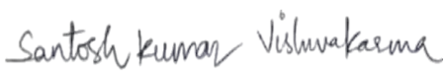

Date: Signature

Place: Ramgarh cantt ,JH (santosh kumar vishwakarma)